|  |  |  |
| --- | --- | --- |
| **Govt. Degree College Khad**   |  | | --- | | **Teh. Haroli, Distt. Una (Himachal Pradesh) 177207** | | **College Logo.jpg** | |
|  |
| Prospectus |
| 2024-25 |
|  |
| **www.gdckhad.in** |
| **gdckhad2016@gmail.com** |

|  |
| --- |
| Govt. Degree College Khad is affiliated to Himachal Pradesh University, Shimla. |

Contents

1. INTRODUCTION OF THE COLLEGE 3

2. TEACHING AND NON-TEACHING FACULTY 4

3. ADMISSION & ADMINISTRATIVE COMMITTEES 5

4. ADMISSION SCHEDULE FOR SESSION 2021-22 7

5. GUIDELINES FOR ADMISSION 7

6. OUTLINES OF UGC CHOICE BASED CREDIT SYSTEM 10

7. BASIC STRUCTURE: DISTRIBUTION OF COURSES 12

8. STUDENT’S CONTINUOUS COMPREHENSIVE ASSESSMENT & EVALUATION 20

9. COLLEGE DUES 21

10. RULES FOR STUDENTS 23

11. COVID-19 APPROPRIATE BEHAVIOUR 24

12. STUDENTS’ FACILITIES/ACTIVITIES 25

13. ROSTER FOR ADMISSION AND RESERVATION 25

14. COLLEGE PRIZE POLICY 28

### INTRODUCTION OF THE COLLEGE

Situated in the beautiful lush green valley formed by the River Swan and overlooking the picturesque Shivalik Hills, Govt. Degree College, Khad is located on the Una-Gagret highway about 20 Km from Una. The popular demand of the masses, social activists, intellectuals and philanthropists of the area culminated in a fruitful manner when the Govt. acceded to the request and a notification was issued in May 2016, facilitating the opening of this college.

It is worth mentioning that this place is popularly known for producing great football players who have represented their teams at National and International level. The college would provide all such potential athletes a platform where they can enhance their skills to achieve their dreams without having to move to far off colleges. In addition to that, the poor, deprived, and under-privileged, unable to go for higher education due to financial constraints, will be highly benefitted.

The College provides holistic education aimed at creating responsible and empowered citizen. It offers two courses at undergraduate level – Bachelor of Commerce and Bachelor of Arts, affiliated with Himachal Pradesh University, Shimla. The College has recently shifted to its own campus.

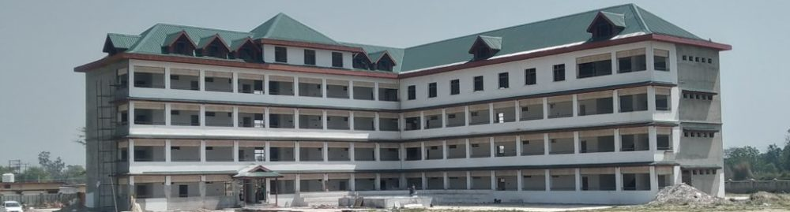

New College building.

Principal and Faculty members with Chief Guest of 2nd Annual Prize Distribution Function, 2020

### TEACHING AND NON-TEACHING FACULTY

|  |  |  |
| --- | --- | --- |
| **PRINCIPAL** | | |
| Dr. Rajindra K. Sharma | M.Com, M.Phil, Ph.D | |
| **TEACHING FACULITY** | | |
| **DEPARTMENT OF COMMERCE** | | |
| Prof. Lakhbir Singh | Assistant Professor | M.Com, MBA, NET Commerce and Management |
| **Vacant** | **Assistant Professor** |  |
| **DEPARTMENT OF ENGLISH** | | |
| Prof. Ravi Raj | Associate Professor | M.A., M.Phil |
| **DEPARTMENT OF HINDI** | | |
| DR. Arti Devi | **Assistant Professor** | M.A,Ph.D. |
| **DEPARTMENT OF ECONOMICS** | | |
| Prof. Rakesh Sharma | Assistant Professor | M.A., M.Phil, NET, SET |
| **DEPARTMENT OF POLITICAL SCIENCE** | | |
| Prof. Virender Singh | Assistant Professor | M.A., M.Phil, SET, NET, JRF, SRF |
| **DEPARTMNET OF HISTORY** | | |
| Prof. Mani Ram | Assistant Professor |  |
| **DEPARTMENT OF MUSIC (Instrumental**) | | |
| VACANT-01 | Assistant Professor |  |
| VACANT-01 | Tabla Vaadak |  |
| **LIBRARY** | | |
| Sh. Vikas Parmar | Assistant Librarian | M.A.English, M. Lib. |
| **Smt. Navjot Badwal Assistant Librarian M.A B.Lib. Sc.**  **NON-TEACHING FACULTY** | | |
| VACANT-01 | Office Superintendent |  |
| Sh. Naresh Kumar | Sr. Assistant |  |
| Sh. Harish Kumar  Sh. Manoj Kumar | Jr. Office Assistant  Jr.Office Assistant |  |
| Sh. Sucha Singh | Peon |  |
| Smt. Indu Bala | Peon |  |
| Smt. Asha Devi | Peon |  |
| Smt. Ravindra Devi | Peon |  |
| Sh. Ashok Kumar | Peon |  |

### ADMISSION & ADMINISTRATIVE COMMITTEES

|  |  |  |  |  |  |  |  |  |  |  |
| --- | --- | --- | --- | --- | --- | --- | --- | --- | --- | --- |
| **ADMISSION COMMITTEES** | | | | | | | | | | |
| **B.Com** | | | | | | | | | | |
| Prof. Ravi Raj: | Convener | | |  | | |  | | | |
|  |  | | | Prof. Lakhbir Singh  Smt. Navjot Badwal | | | Member  Member | | | |
| **B.A.** | | | | | | | | | | |
| Prof. Rakesh Sharma | Convener | | |  | | |  | | | |
|  |  | | | Prof. Virender Singh  Prof Mani Ram  Sh. Vikas Parmar | | | Member  Member  Member | | | |
| **COLLEGE ADVISORY COMMITTE** | | | | | | | | | |
| 1. Prof. Ravi Raj | | Convener | | | 2. Dr. Arti Devi | | | Member | |
| 3. Prof. Rakesh Sharma | | Member | | |  | | |  | |
|  | |  | | |  | | |  | |
| **ANTI RAGGING SQUAD/DISCIPLINE COMMITTEE** | | | | | | | | | |
| 1. Prof. Ravi Raj | | Convener | | | 2. Prof. Rakesh Sharma | | | Member | |
| 3. Prof. Virender Singh | | Member | | | 4. Prof. Lakhbir Singh | | | Member | |
|  | |  | | |  | | |  | |
| **WOMEN GRIEVANCES REDRESSAL CELL** | | | | | | | | | |
| 1. Dr. Arti Devi | | Convener | | | 2. Smt. Navjot Badwal | | | Member | |
| 3. Smt. Ravindra Devi | | Member | | |  | | |  | |
|  | |  | | |  | | |  | |
|  | |  | | |  | | |  | |
| **CAREER GUIDANCE AND COUNSELING CELL** | | | | | | | | | |
| 1. Prof. Rakesh Sharma | | Convener | | | 2. Prof. Lakhbir Singh | | | Member | |
|  | |  | | |  | | |  | |
| **WATER MANAGEMENT COMMITTEE** | | | | | | | | | |
| 1. Prof. Virender Singh | | Convener | | | 2. Sh. Naresh Kumar | | | Member | |
| 3. Sh. Sucha Singh | | Member | | |  | | |  | |
| **INTERNAL QUALITY ASSURANCE CELL.**   1. **Prof. Ravi Raj Convener 2. Dr. Arti Devi Member**   **3 Prof. Rakesh Sharma Member** | | | | | | | | | |  | | |  | |  |
| **HOUSE EXAMINATION** | | **COMMITTEE** | | |  | | |  | |
| 1. Prof. Rakesh Sharma | | Convener | | | 2. Sh. Manoj Kumar | | | Member | |
| 3 Smt. Indu Bala | | Member | | |  | | |  | |
| **CULTURAL COMMITTEE** | | | | | | | | | |
| 1. Dr. Arti Devi | | Convener | | | 2. Prof. Mani Ram | | | Member | |
| 3. Smt. Navjot Badwal | | Member | | |  | | |  | |
|  | |  | | |  | | |  | |
|  | | **SPORTS COMMITTEE** | | |  | | |  | |
|  | |  | | |  | | |  | |
|  | | | | | | | | | |  | | | |
|  | | **LEGAL AID COMMITTEE** | | |  | | |  | |
|  | |  | | |  | | |  | |
| **1.Prof. Rakesh Sharma Convener 2. Sh. Harish Kumar Member** | | | | | | | | | |
|  | |  | | |  | | |  | |
|  | |  | | |  | | |  | |
|  | | | | | | | | | | | |
|  | | |  | | |  | | |  | | |

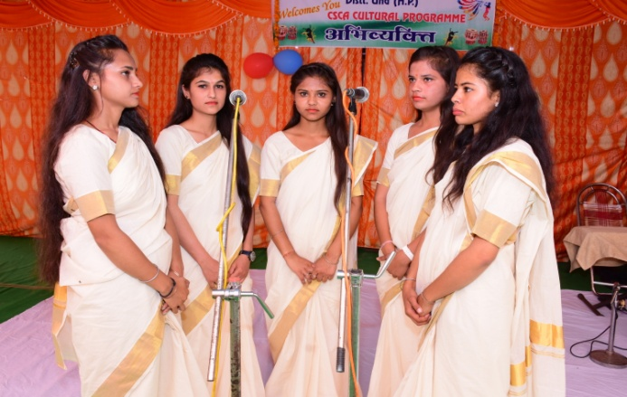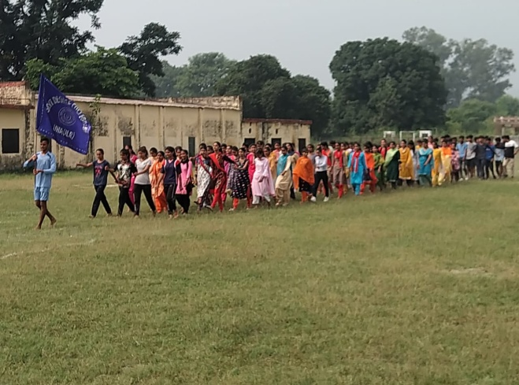

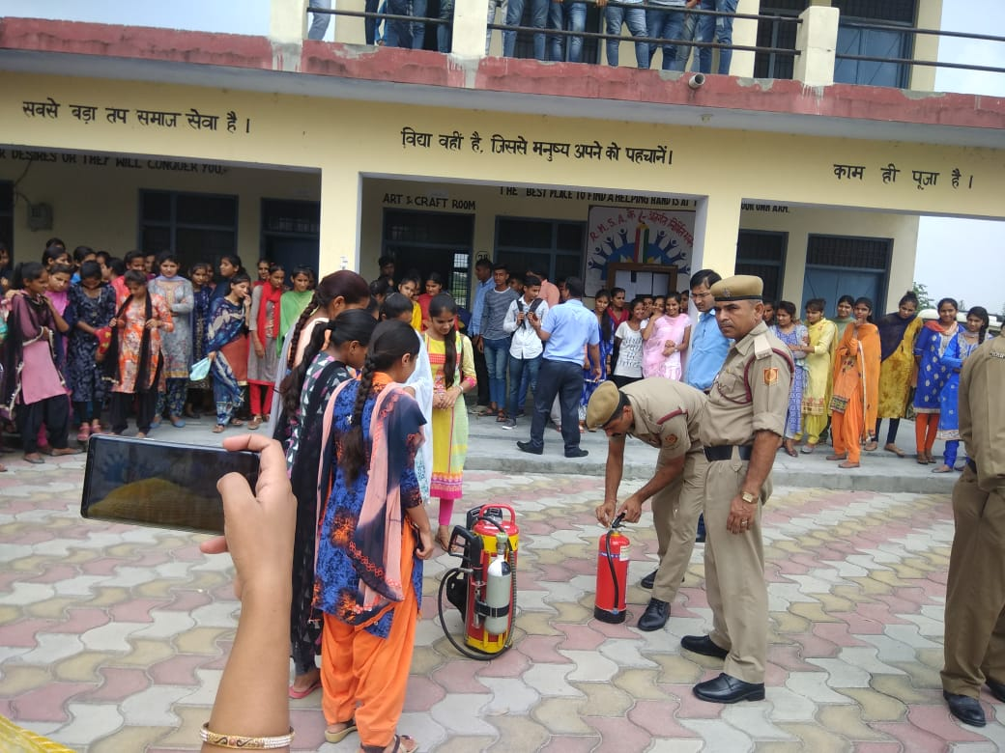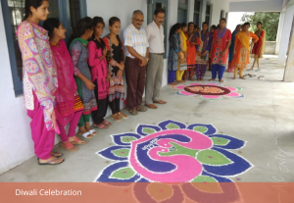

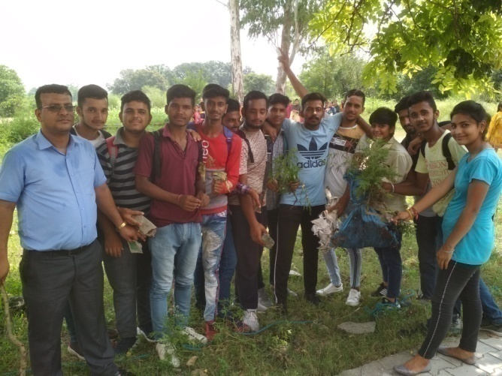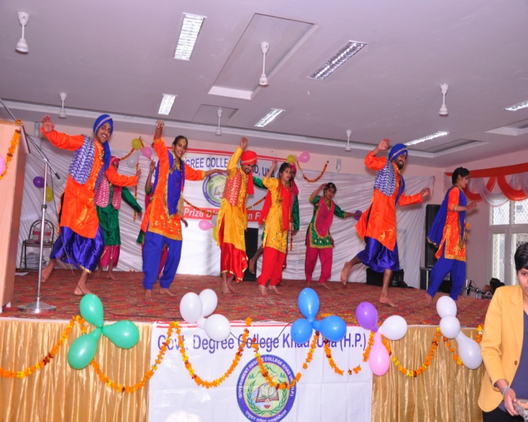

Glimpses of some activities

### ADMISSION SCHEDULE FOR SESSION 2024-25

1. Issue of Prospectus/Launch of Online Admission Portal: 3rd June 2024 onwards
2. Dates to apply for Admissions through Online Portal: 3rd June 2024 to 15th July2024

* Display of Merit List: 16th July 2024

1. Fee Deposit: Up to 16th July to 19th July 2024
2. Display of 2nd Merit List: 20th July 2024 (up to 11: am)
3. Fee Deposit (2nd Merit List): 20th July 2024 (up to 5.00: am)
4. Orientation for First Year Students 22nd July 2024
5. Regular Teaching Commencement: 23rd July 2024 onwards

### GUIDELINES FOR ADMISSION

#### 5.1 COURSES OFFERED

**Bachelor of Arts (B.A.)** – English, Hindi, Economics, History, Music and Political Science.

**Bachelor of Commerce (B.Com)**

#### 5.2 ELIGIBILITY CONDITIONS

A pass in the Senior Secondary (+2) Examination or an examination equivalent thereto of a Board/University established by law in India with pass in four written subjects (including English).

**Bachelor of Arts (BA):**At least 33% marks.

**Bachelor of Commerce (B.Com):**At least 40% marks (for girls 33%).  The Minimum Eligibility for Non-Commerce Students shall be 45% marks in +2 examination (Only those students who have opted either Mathematics or Economics in +2).

**Important:**

* **Applicant who has passed the qualifying examination with commerce stream shall be given preference in admission to B.Com Programme.**
* Applicant must not be more than 23 years of age (25 years for girl applicant, 26 years for SC and ST applicant and 28 years for specially-abled applicant) on 1st July of the corresponding year. The Vice-Chancellor, Himachal Pradesh University, Shimla shall have the power to permit age relaxation up to a maximum period of 6 months.
* Applicant can seek admission to the first year of the course(s) only if he has English as one of the compulsory subjects in the 10+2 examination.
* Admission of a student is liable to be cancelled in case he/she furnishes incomplete/ wrong/ false information or in case of concealment of facts. Disciplinary action will also be taken against such a candidate.

#### 5.3 GENERAL ADMISSION RULES

1. Admission will be made on the recommendation of the Admission Committee.
2. Admission will be strictly on fulfillment of eligibility conditions.
3. All admissions will be provisional subject to the approval of Himachal Pradesh University, Shimla.
4. All terms and conditions of admission and fee structure can be changed or modified as per the directions of Himachal Pradesh University, Shimla and the Govt. of Himachal Pradesh.
5. Applicant must upload scanned original certificates on admission portal.
6. Applicant having a gap of one or more years in their studies will have to accept an undertaking.
7. Every student seeking admission in any class will be required to pay Rs. 600/- per annum towards PTA fund. Fees and funds once deposited will not be refunded.
8. Girl students seeking admission in any class must upload scanned copy of H.P. Bonafide certificate to avail concessional fees (Tuition Fee Only).
9. Students seeking exemption from Tuition Fee for disability must attach an attested copy of 40% disability certificate.
10. The admission of a student who is seeking admission to Three Years Degree Course (TDC) II or TDC III on the basis of educational qualifications acquired from the University other than the Himachal Pradesh University, Shimla shall be regularized on the basis of equivalence of syllabi as and when decided by the Himachal Pradesh University, Shimla.
11. Candidates coming from school of education Board/University other than HP Board of school education/ Himachal Pradesh University, Shimla must submit copy of migration certificate in the college.

#### 5.4 ADMISSION PROCEDURE

The College has developed an online admission portal, every candidate intended to take admission in the college is required to apply online through this portal, which is available at <https://admission.gdckhad.in/>. **All New and Old Candidates must Register and Apply before Last Date.** Before applying candidate must have following document/particulars handy:

1. A valid own Mobile number. Please keep it active, at least until the admission process is complete, as all communication will be sent through SMS.
2. Mobile number must belong to the candidate himself/herself or someone in the family. DO NOT fill in friend’s or Cyber CAFÉ’s Mobile number.
3. An E-Mail ID belonging to the candidate or someone in the family.
4. Aadhar number or Enrolment number.
5. Recent passport size photograph and signature.
6. Detailed Marks Card of previous passed examination.
7. Candidates wishing to apply for Reservation must have a valid supporting document.
8. In the Registration Section please select the Course and Semester/Year in which you are seeking admission. Subject selection will be visible after you successfully register and Login into portal.
9. It is advised to regularly check email, SMS and visit College site for latest updates over admission process.

**5.5 DOCUMENTS REQUIRED FOR ONLINE ADMISSION**

1. Scanned copies of all original Board certificates from matric onwards.
2. Recent soft copy of passport size photograph of minimum 200 x 200 pixel resolution and less than 200 KB in size.
3. Scanned Signature.
4. Scanned copy of character certificate from the head of institution last attended. The original character certificate to be submitted in the college.
5. In case of student who has discontinued his/her studies for one or more year the character certificate must be supplemented by another character certificate obtained from Class I Gazetted Officer or the Panchayat Pradhan of the village/illaka concerned.

**Note:** The character certificate must not have been issued more than six months prior to the date of admission.

1. Students with a gap of one year or more have to accept declaration mentioned under Sub-Categories.
2. Scanned SC/ST/OBC/EWS certificate for those seeking relaxation or weightage.
3. The candidates who belong to IRDP, NCC, NSS, Sports, Cultural Quota and those seeking relaxation or weightage must upload scanned copy of certificate.
4. The candidates from other Boards/University, must submit in the College:
   1. Eligibility certificate from H.P. Board/University showing equivalence.
   2. Migration Certificate.
5. All girl candidates have to upload scanned copy of Bonafide Himachali Certificate for getting Exemption from Tuition fee.

**5.6 ONLINE ADMISSION PROCEDURE**

1. In case a candidate is using the site for first time and do not have a Login ID and password click on NEW REGISTRATION to register on website by filling his/her name, gender, email ID, Mobile Number and by selecting his course. On clicking REGISTER button, candidate will get LOGIN and PASSWORD, to be used for further process. Candidate will be able to login to the admission portal by using these credentials in all future visits to this portal.

The online application form is to be filled up by the applicant carefully after reading all rules, eligibility conditions.

1. After filling login-password, click on LOGIN. You will be on a screen to fill application form.

Various columns and dropdowns will appear on screen and candidate will have to fill or choose as applicable in his/her case and complete all the information. Candidate will also be required to upload his/her photograph, scanned signature and scanned documents. All data will be saved against candidate’s registered ID. Candidate will be able to view and can modify the information, if final form is not submitted.

1. Click on PAYMENT.
2. On completion of application form, student will have option to make the payment of Rs 50/- online using debit card, credit card, net banking. A receipt will be generated after payment has been successfully made online.
3. College authorities will scrutinize the documents attached by the candidates to confirm that there is no shortcoming or deficiency in the application form. On any deficiency, a SMS/email will be sent on candidate’s number/email ID. Candidate will be able to check the status of his/her application online with his/her password on the admission portal [www.admission.gdckhad.in](http://www.admission.gdckhad.in) in this regard.
4. On satisfaction of college authorities, admission will be granted subject to eligibility and availability of seats, a confirmation SMS/email will be sent on candidate’s number/email ID.
5. The candidate will be required to submit the fee ONLINE.
6. In case the student fails to submit his/her fee online before due date, the seat will be offered to the next eligible candidate.
7. Student will get information, like roll no., time-table etc. through SMS/email, and from College Notice Board.

**Get Log in ID & Password**

**On Registration**

**For All Further Procedure**

**Go to new Registration**

**Click Undergraduate**

Go **to admission.gdckhad.in**

**Select Course - Fill in Name, Gender, E-mail ID, Mobile No.**

### OUTLINES OF UGC CHOICE BASED CREDIT SYSTEM

**1. Core Course** (12 papers for regular courses): The Papers under this category are going to be taught uniformly across all universities with 30% deviation proposed in the draft. The purpose of fixing core papers is to ensure that all the institutions follow a minimum common curriculum so that each institution/University adheres to common minimum standard. Also the course designed for papers under this category aim to cover the basics that a student is expected to imbibe in that particular discipline. A course, which should compulsorily be studied by a candidate as a core requirement is termed as a Core course.

**2. Elective Course:** Generally a course which can be chosen from a pool of courses and which may be very specific or specialized or advanced or supportive to the discipline/subject of study or which provides an extended scope or which enables an exposure to some other discipline/ subject/ domain or nurtures the candidate’s proficiency/skill is called an Elective Course.

**2.1 Discipline Specific Elective (DSE) Course** (4 papers for regular courses)

Elective courses offered under the main discipline/subject of study are referred to as Discipline Specific Elective. The list provided under this category are suggestive in nature and each university has complete freedom to suggest its own papers under this category based on their experience, specialization, requirements, scope and need.

The University/Institute may also offer discipline related Elective courses of interdisciplinary nature (to be offered by main discipline/subject of study).

**2.2 Dissertation/Project*:** An elective course designed to acquire special/advanced knowledge, such as supplement study/support study to a project work, and a candidate studies such a course on his own with an advisory support by a teacher/faculty member is called dissertation/project.

**2.3 Generic Elective (GE) Course** (2 each for B.A./B.Com. regular courses) : An elective course chosen from an unrelated discipline/subject, with an intention to seek exposure beyond discipline/s of choice is called a Generic Elective. The purpose of this category of papers is to offer the students the option to explore discipline of interest beyond the choices they make in Core and Discipline Specific Elective papers. The list provided under this category is suggestive in nature and each university has complete freedom to suggest its own papers under this category based on its expertise, specialization, requirements, scope and need. **P.S.**: A core course offered in a discipline/ subject may be treated as an elective by other discipline/subject and *vice versa* and such electives may also be referred to as Generic Elective.

**3. Ability Enhancement Course (AEC):** The Ability Enhancement (AE) Courses may be of two kinds: Ability Enhancement Compulsory Courses (AECC) and Skill Enhancement Courses (SEC). “AECC” courses are the courses based upon the content that leads to Knowledge enhancement. These are mandatory for all disciplines. SEC courses are value-based and skill-based and are aimed at providing hands-on-training, competencies, skills, etc.

**3.1 Ability Enhancement Compulsory Courses (AECC):** (2 papers for regular courses)

i) Environmental Science

ii) English Communication/ Hindi Communication/MIL/Communication.

**3.2 Skill Enhancement Courses (SEC)** (4papers for regular courses): These courses may be chosen from a pool of courses designed to provide value-based and/or skill-based knowledge and should contain theory and lab/ hands-on/training/field work. The main purpose of these courses is to provide students life-skills in hands-on mode so as to increase their employ ability. The list provided under this category is suggestive in nature and each university has complete freedom to suggest its own papers under this category based on its expertise, specialization, requirements, scope and need.

**4. Practical/tutorials** (One each with every core and discipline/generic specific elective paper): The list of practicals provided is suggestive in nature and each university has the freedom to add/subtract/edit practicals from the list depending on their faculty and infrastructure available. Addition will however be of similar nature.

**SCHEME FOR CHOICE BASED CREDIT SYSTEM IN B.A/ B.COM.**

|  |  |  |  |  |  |
| --- | --- | --- | --- | --- | --- |
|  | **Core Course (12)** | **Ability Enhancement Compulsory Course (AECC) (2)** | **Skill Enhancement Course (SEC) (2)** | **Discipline Specific Elective DSE (4)** | **Generic Elective GE(2)** |
| **1st Year** | English MIL -1  DSC-I A  DSC-2 A  Hindi/ MIL/-1  DSC-1 B  DSC-2 B | Environment Science  English (Writing Skill) |  |  |  |
| **2nd Year** | English MIL -2  DSC-I C  DSC-2 C  Hindi/ MIL/2  DSC-1 D  DSC-2 D |  | SEC-1  SEC-2 |  |  |
| **3rd Year** |  |  | SEC-3  SEC-4 | DSE-1A  DSE-2A  DSE-1B  DSE-2B | GE-1  GE-2 |

#### 6.1 Annual System

An academic year comprising 180 working days. With six working days in a week this would mean that each academic year will be having 180/6=30 teaching/working weeks. Considering that each teaching day has 5 teaching/working hours, a teaching week would have 5x6=30 working/teaching hours and each academic year will have 30x30=900 teaching hours available for each student.

A candidate has to opt for eight (8) subjects, to be studied throughout the year. In order to be promoted to next year of the course, it is compulsory to pass in minimum six (06) subjects with 35% marks in term end/Internal assessment, with 40% in aggregate, is the basic condition to be declared passed in the subject.

#### 6.2 Credits

The term ‘credit’ refers to the weight age given to a course, usually in terms of the Number of instructional hours per week assigned to it. This explains why they are usually called credit hours’. The credits also determine the volume contents and delivery of programme such as lectures, tutorials, practical, assignments etc.

For the purpose of credit determination, instruction is divided into three components :-

**(a) Lectures (L):**

Classroom lectures of one hour duration.

**(b) Tutorials (T):**

Special, elaborate instructions on specific topics (from Lectures) of one hour duration.

**(c) Practical (P) :**

Laboratory or field exercises in which the student has to perform experiments or other practical work of two hour duration.

Each one of these components is considered as equal to one credit. One lecture (L) as well as one Tutorial (T) of one hour a week is considered as one credit, whereas one Practical (P) of two hours a week is considered as one credit. The total weightage given to a course in terms of credits will be equal to L+T+P, where L is the number of one hour Tutorials per week, and P is the number of two hour Practicals per week. This can be written in symbols as: C=L+T+P. Where, C is the credit weight age for a particular course.

The total minimum credits required for an under graduate degree programme is one hundred thirty two.

### BASIC STRUCTURE: DISTRIBUTION OF COURSES

|  |  |  |  |
| --- | --- | --- | --- |
| 1 | **Ability-Enhancement Compulsory Course (AECC)** | 2 Papers of 4 Credit Hrs. each (Total Credit Hrs. 4X2) | 8 |
| 2 | **Skill-Enhancement Elective Course (SEC)** | 4 Papers of 4 Credit Hrs. each (Total Credit Hrs. 4X4) | 16 |
| 3 | **Core Course** | 12 Papers of 6 Credit Hrs. each (Total Credit Hrs. 12X6)  (5 Lectures and 1 Tutorial) | 72 |
| 4 | **Discipline Specific Elective (DSE)** | 4 Papers of 6 Credit Hrs. each (Total Credit Hrs. 3X6)  (5 Lectures and 1 Tutorial) | 24 |
| 5 | **Generic Elective (GE)** | 2 Papers of 6 Credit Hrs. each (Total Credit Hrs. 3X6)  (5 Lectures and 1 Tutorial) | 12 |
|  | **Total Credit Hours** |  | 132 |

#### 7.1 Programme Structure: B. Com

|  |  |  |
| --- | --- | --- |
| **Course Code** | **Course Title** | **Course Type** |
| **1st Year** | | |
| ENVS2AECC02 | Environmental Studies | Ability-Enhancement  Compulsory Course (AECC)-1 |
| BC 1.1 | Financial Accounting | Core Course C-1 |
| BC 1.2 | Business Organisation and Management | Core Course C-2 |
| ENGCE101 | English-1 | Core Course C-3 |
| ENGAECC104 | Writing Skills | Ability-Enhancement  Compulsory Course (AECC)-2 |
| BC 1.3 | Business Law | Core Course C-4 |
| BC 1.4 | Business Statistics and Mathematics | Core Course C-5 |
| HIND101 | Prayojanmoolak Hindi | Core Course C-6 |
|  | | |
| **2nd Year** | | |
| BC 2.1 | Company Law | Core Course C-7 |
| BC 2.2 | Income Tax Law and Practice | Core Course C-8 |
| ENGCE201 | English-2 | Core Course C-9 |
| BC 2.3 | Computer Applications in Business | Skill-Enhancement Elective Course (SEC)-1 |
| HIND201 | Anivarya Hindi ‘Rachna Punj’ | Core Course C-10 |
| BC 2.4 | Corporate Accounting | Core Course C-11 |
| BC 2.5 | Cost Accounting | Core Course C-12 |
| BC 2.6 | E-Commerce | Skill-Enhancement Elective Course (SEC)-2 |
|  | | |
| **3rd Year** | | |
| BC 3.1(c) | Corporate Governance and Auditing | Discipline Specific Elective (DSE)-1 |
| BC 3.2(a) | Fundamentals of Financial Management | Discipline Specific Elective (DSE)-2 |
| BC 3.3 | Entrepreneurship | Skill-Enhancement Elective Course (SEC)-3 |
| ECONA313 | Economy of Himachal Pradesh | Generic Elective (GE)-1 |
| BC 3.5(c) | Management Accounting | Discipline Specific Elective (DSE)-3 |
| BC 3.6(c) | Fundamentals of Investment | Discipline Specific Elective (DSE)-4 |
| BC 3.7 | Personal Selling & Salesmanship | Skill-Enhancement Elective Course (SEC)-4 |
| ECONA314 | Indian Economy | Generic Elective (GE)-2 |

#### 7.2 Subject Combinations for B.A.

**B.A. 1st Year**

|  |  |  |  |
| --- | --- | --- | --- |
| **Core Courses (6*2 credit )**  **Discipline Specific Course**  **DSC-1A**  **DSC -1B** | **Core Elective (6*2 credit) (Any One)**  **DSC-2A**  **DSC-2B** | **Compulsory 1**  **Compulsory 2**  **(6*2 Credit)** | **Ability-Enhancement Compulsory Course (4*2 credit )**  **AECC 1**  **AECC 2** |
| **English** | I. Economics  II. Music (Instrumental)  III. History | I. Core English  II. Core Hindi | I. Environment Science  II. English – Writing Skills |
| **Hindi** | I. History  II. Political Science | I. Core English  II. Core Hindi | I. Environment Science  II. English – Writing Skills |
| **Economics** | I. History  II. Political Science | I. Core English  II. Core Hindi | I. Environment Science  II. English – Writing Skills |
| **Political Science** | I. Economics  II. History  III. Hindi | I. Core English  II. Core Hindi | I. Environment Science  II. English – Writing Skills |
| **History** | I. Hindi  II. Political Science  III. Economics | I. Core English  II. Core Hindi | I. Environment Science  II. English – Writing Skills |
| **Music (Instrumental)** | I. English  II. Economics | I. Core English  II. Core Hindi | I. Environment Science  II. English – Writing Skills |

**B.A. 2nd Year**

|  |  |  |  |
| --- | --- | --- | --- |
| **Core Courses (6*2 credit )**  **DSC-1C**  **DSC -1D** | **Core Elective (6*2 credit) (Any One)**  **DSC-2C**  **DSC-2D** | **Compulsory 3**  **Compulsory 4**  **(6*2 credit)** | **Skill Enhancement Course (4*2 credit)**  **SEC 1**  **SEC 2** |
| **English** | I. Economics  II. Music (Instrumental)  III. History | I. Hindi  II. English | English |
| **Hindi** | I. History  II. Political Science | I. Hindi  II. English | Hindi |
| **Economics** | I. History  II. Political Science | I. Hindi  II. English | Economics |
| **Political Science** | I. Economics  II. History  III. Hindi | I. Hindi  II. English | Political Science |
| **History** | I. Hindi  II. Political Science  III. Economics | I. Hindi  II. English | History |
| **Music (Instrumental)** | I. English  II. Economics | I. Hindi  II. English | Music (Instrumental) |

**B.A. 3rd Year**

|  |  |  |  |
| --- | --- | --- | --- |
| **Core Courses (6*2 credit )**  **Discipline Specific Elective Course**  **DSE-1A**  **DSE -1B** | **Core Elective (6*2 credit) (Any One)**  **DSE-2A**  **DSE-2B** | **SEC 3**  **SEC 4**  **(4*2 credit)** | **Generic Elective (6*2 credit)**  **GE 1**  **GE 2** |
| **English** | I. Economics  II. Music (Instrumental)  III. History | English | Political Science |
| **Hindi** | I. History  II. Political Science | Hindi | I. Economics  II. English  III. History |
| **Economics** | I. History  II. Political Science | Economics | I. History  II. English  III. Political Science |
| **Political Science** | I. Economics  II. Hindi  III. History | Political Science | I. History  II. English  III. Economics |
| **History** | I. Hindi  II. Political Science  III. Economics | History | I. Economics  II. English |
| **Music (Instrumental)** | I. English  II. Economics | Music (Instrumental) | Political Science |

#### 7.3 Programme Structure: B.A.

**FIRST YEAR**

|  |  |  |  |  |  |  |
| --- | --- | --- | --- | --- | --- | --- |
| **Course** | **ENGLISH** | **HINDI** | **ECONOMICS** | **POLITICAL SCIENCE** | **HISTORY** | **MUSIC** |
| DSC1-A | English Literature-1  (ENGDSC102) | Hindi Sahitya Ka Itihaas  (HIND102) | Principles of Micro Economics-I  (ECONA101) | Introduction to Political Theory  (POLS101) | History of India from the Earliest Times upto c. 300 CE  (HIST(A)101) | Theory of Indian Music (Basic Principles of Indian Music & Biographies of Musicians Composers and Musicologists)  (MUSA101TH) |
| DSC2–A |  |  |  |  |  |  |
| AECC -1 | Environment Science (ENVS2AECC02) | Environment Science (ENVS2AECC02) | Environment Science (ENVS2AECC02) | Environment Science (ENVS2AECC02) | Environment Science (ENVS2AECC02) | Environment Science (ENVS2AECC02) |
| Compulsory-1 | English-1  (ENGCE101) | English-1  (ENGCE101) | English-1  (ENGCE101) | English-1  (ENGCE101) | English-1  (ENGCE101) | English-1  (ENGCE101) |
| DSC1-B | English Literature-2  (ENGDSC103) | Madhyakalin Hindi Kavita  (HIND103) | Principles of Micro Economics-II  (ECONA102) | Indian Government and Politics  (POLS102) | History of India c. 300-1206  (HIST(A)102) | Theory of Indian Music (General and Biographies of Musicians Composers and Musicologist)  (MUSA103TH) |
| DSC 2–B |  |  |  |  |  |  |
| AECC–2 | English (Writing Skills) (ENGAECC104) | English (Writing Skills) (ENGAECC104) | English (Writing Skills) (ENGAECC104) | English (Writing Skills) (ENGAECC104) | English (Writing Skills) (ENGAECC104) | English (Writing Skills)  (ENGAECC104) |
| Compulsory -2 | Prayojanamoolak Hindi  (HIND101) | Prayojanamoolak Hindi  (HIND101) | Prayojanamoolak Hindi  (HIND101) | Prayojanamoolak Hindi  (HIND101) | Prayojanamoolak Hindi  (HIND101) | Prayojanamoolak Hindi  (HIND101) |

**SECOND YEAR**

|  |  |  |  |  |  |  |
| --- | --- | --- | --- | --- | --- | --- |
| **Course** | **ENGLISH** | **HINDI** | **ECONOMICS** | **POLITICAL SCIENCE** | **HISTORY** | **MUSIC** |
| DSC1-C | British Literature (Play and Novel)  (ENGDSC202) | Adhunik Hindi Kavita  (HIND202) | Principles of Macro Economics-I  (ECONA201) | Comparative Government and Politics  (POLS201) | History of India, c. 1206-1707  (HIST(A)203) | Ancient Granthas & Contribution of Musicologists  (MUSA201TH) |
| DSC2-C |  |  |  |  |  |  |
| SEC-1 | Creative Writing, Book & Media Reviews  (ENG AEEC/SEC 204) | Karyalayi Hindi  (HIND204) | Economics of Rural Development  (ECONA204) | Legislative Support  (POLS 203) | Historical Tourism  (HIST(A)213) | Hindustani Music  (MUSA205PR) |
| Compulsory-3 | English-2  (ENGCE201) | English-2  (ENGCE201) | English-2  (ENGCE201) | English-2  (ENGCE201) | English-2  (ENGCE201) | English-2  (ENGCE201) |
| DSC1-D | Literacy Cross Currents  (ENGDSC203) | Hindi Gadya Sahitya  (HIND203) | Principles of Macro Economics-II  (ECONA202) | Introduction to International Relations  (POLS202) | History of India, c. 1707-1950  (HIST(A)204) | Medieval Granthas & Contributions of Musicians & Musicologists  (MUSA203TH) |
| DSC2-D |  |  |  |  |  |  |
| SEC-2 | Translation Studies & Principles of Translation  (ENG AEEC/SEC 205) | Anuvad Vigyaan  (HIND206) | Demography  (ECONA206) | Public Opinion and Survey Research  (POLS204) | An Introduction to Archeology  (HIST(A)215) | Hindustani Music  (MUSA206PR) |
| Compulsory-4 | Anivarya Hindi ‘Rachna Punj’  (HIND201) | Anivarya Hindi ‘Rachna Punj’  (HIND201) | Anivarya Hindi ‘Rachna Punj’  (HIND201) | Anivarya Hindi ‘Rachna Punj’  (HIND201) | Anivarya Hindi ‘Rachna Punj’  (HIND201) | Anivarya Hindi ‘Rachna Punj’  (HIND201) |

**THIRD YEAR**

|  |  |  |  |  |  |  |
| --- | --- | --- | --- | --- | --- | --- |
| **Course** | **ENGLISH** | **HINDI** | **ECONOMICS** | **POLITICAL SCIENCE** | **HISTORY** | **MUSIC** |
| DSE-1A | Soft Skills  (ENGDSE303) | Lok Sahitya  (HIND305) | Economy of Himachal Pradesh  (ECONA303) | Administration and Public Policy: Concepts & Theories  (POLS301(B)) | Modern and Contemporary World History I: 1871-1919  (HIST(A)305) | Theory of Indian Music and Study of Ancient Granthas and Rãgas  (MUSA303TH) |
| DSE- 2A |  |  |  |  |  |  |
| SEC-3 | Technical Writing  (ENG AEEC/SEC 301) | Rang Aalekh Evam Rangmanch  (HIND301) | Public Finance  (ECONA310) | Democratic Awareness through Legal Literacy  (POLS303) | Indian History and Culture  (HIST(A)317) | Value based Practical Oriented Course for Hindustani Music  (MUSA301PR) |
| GE-1 | Contemporary India: Women & Empowerment  (ENGGE306) |  | Economy of Himachal Pradesh  (ECONA313) | Society, Economy & Politics in Himachal Pradesh  (POLS 305) | Women in Indian History  (HIST(A)309) |  |
| DSE- 1B | Academic Writing and Composition  (ENGDSE304) | Chayavaadotar Hindi Kavita  (HIND306) | Development Economics  (ECONA305) | Democracy & Governance  (POLS 302(A)) | Modern and Contemporary World History II: 1919-1992  (HIST(A)307) | Theory of Indian Music and Ghrarana Tradition  (MUSA305TH) |
| DSE-2B |  |  |  |  |  |  |
| SEC-4 | Business Communication  (ENG AEEC/SEC 302) | Samachar Sankalan aur Lekhan  (HIND304) | Money & Banking  (ECONA311) | Conflict and Peace Building  (POLS304) | Introduction to Indian Art  (HIST(A)319) | Value based Practical Oriented Course for Hindustani Music  (MUSA302PR) |
| GE-2 | Literature from Himachal  (ENGGE305) |  | Development Economics  (ECONA315) | Human Rights, Gender and Environment  (POLS306) | History of Himachal Pradesh, 1815-1972  (HIST(A)312) |  |

**Note:** The eligibility of admission & subject combinations shall depend totally on notification of Govt. of Himachal Pradesh/ Himachal Pradesh University, Shimla.

**HP University has proposed to implement the pronsionsot NEP (National Education Policy 2020) from this academic year i.e 2024-25. The College to the directions from Govt. of Himachal Pradesh & HP University as and when notified.**

### STUDENT’S CONTINUOUS COMPREHENSIVE ASSESSMENT & EVALUATION

All courses involve an evaluation system of students that has the following two components:

* 1. Continuous Comprehensive Assessment (CCA) accounting for 30% of final grade.
  2. Annual examination accounting for 70% of the final grade.

In practical subjects, practical exams will be of 20% and annual examination of 50% weightage.

**CCA Scheme**

CCA will account 30% of total marks i.e. 100, which a student will get in a course. The breakup of 30% i.e. 30 marks is given as under:

* Minor test (Class test for 5 marks+ House test for 10 marks) 15 marks
* Assignments/ seminars/ class test/ tutorials/ quiz 10 marks
* Attendance 5 marks

**(A) Mode of conducting Minor Test (15 Marks) will be as under:-**

Class room test after completion of the 40% of syllabus.

House Test will be conducted after the completion of 75% syllabus.

**(B) Distribution of marks for evaluation of Tutorial/ Home Assignment etc.:-**

5 marks are assigned for the quality of contents and structure of the assignment.

5 marks are assigned for the clarity of language of the spirit (Hindi/ English) and its presentation in the class room.

Total marks 5+5 =10 marks

**(C) Classroom Attendance**

Each student will have to attend a minimum of 75% Lectures/ Tutorials/ Practicals. A student having less than 75% attendance will not be allowed to appear in the annual examination. Those having greater than 75% attendance will be awarded CCA marks as follows (out of 5):

i) 75% to 79% - 1 mark

ii) 80% to 84% - 2 marks

iii) 85% to 89% - 3 marks

iv) 90% to 94% - 4 marks

v) More than 95% - 5 marks

A student will have to pass both the components i.e. CCA and EYE (End Year Examination) separately (with at least 40% marks EACH in CCA, practical and EYE) to become eligible to be declared successful for the course.

### COLLEGE DUES

**(Funds details as per Govt. Notification)**

**For the Academic Session 2023-24**

|  |  |
| --- | --- |
| **Particular** | **Fees (In Rs.)** |
| **A. Government Fund** |  |
| **Annual** |  |
| Admission | 25 |
| **Monthly** |  |
| Tuition Fees (Boys & Non-Himachali Girls) | 50 |
| **B. University Fund** |  |
| **Annual** |  |
| Holiday Home | 1 |
| Welfare | 15 |
| Sports Fund | 15 |
| University Development Fund | 250 |
| **C. College Fund** |  |
| **College refundable** |  |
| Library Security | 100 |
| **College Non Refundable** |  |
| **Annual Charges** |  |
| Medical Aid | 6 |
| Campus Development | 10 |
| Book Replacement Fund | 25 |
| Furniture Repair/Replacement Fund | 10 |
| Magazine Fund | 50 |
| NCC Fund | 10 |
| Student Aid Fund | 2 |
| Cultural Activity Fund | 20 |
| Computer & Internet Facility | 20 |
| House Exam | 80 |
| Identity Card | 20 |
| Duplicate Identity Card | 20 |
| **Monthly Charges** |  |
| Amalgamated Fund | 25 |
| Sports Fund | 20 |
| Building Fund | 10 |
| Rover and Rangers Fund | 5 |
| Practical Fee (Per Subject) | 180 |
| **NOTES** |  |
| 1. Re-Admission Fees :           First Time | 100 |
| Second Time | 200 |
| 2. Absence Fine Per Period | 1 |
| 3. Absence Fine (Practical) | 3 |
| 4. Absence Fine (House Exam Per Paper) | 10 |
| 5. Late Return of Library Books Per Day | 1 |
| 6. Late Payment of Dues per Day | 1 |
| 7. Late Admission Fee per Day | 10 |

**Fee Structure for B.A. & B.Com**

|  |  |  |  |  |  |  |
| --- | --- | --- | --- | --- | --- | --- |
|  | **B.A. 1st Year** | **B.Com 1st Year** | **B.A. 2nd Year** | **B.Com 2nd Year** | **B.A. 3rd Year** | **B.Com 3rd Year** |
| Admission | 25 | 25 | 25 | 25 | 25 | 25 |
| Tuition Fees (Boys) | 600 | 600 | 600 | 600 | 600 | 600 |
| Continuation |  |  | 10 | 10 | 10 | 10 |
| University Sports Fees | 15 | 15 | 15 | 15 | 15 | 15 |
| University Youth Welfare Fee | 15 | 15 | 15 | 15 | 15 | 15 |
| University Holiday Fee | 1 | 1 | 1 | 1 | 1 | 1 |
| Library Security | 100 | 100 | 0 | 0 | 0 | 0 |
| House Exam | 80 | 80 | 80 | 80 | 80 | 80 |
| Magazine Fee | 50 | 50 | 50 | 50 | 50 | 50 |
| Amalgamated Fund | 300 | 300 | 300 | 300 | 300 | 300 |
| Medical Aid | 6 | 6 | 6 | 6 | 6 | 6 |
| Student Aid | 2 | 2 | 2 | 2 | 2 | 2 |
| NCC Fund | 10 | 10 | 10 | 10 | 10 | 10 |
| Identity Card | 20 | 20 | 20 | 20 | 20 | 20 |
| Building Fund | 120 | 120 | 120 | 120 | 120 | 120 |
| Campus Development Fund | 10 | 10 | 10 | 10 | 10 | 10 |
| Furniture Repair/Replacement Fund | 10 | 10 | 10 | 10 | 10 | 10 |
| Culture Activity Fund | 20 | 20 | 20 | 20 | 20 | 20 |
| Book Replacement Fund | 25 | 25 | 25 | 25 | 25 | 25 |
| Rover and Rangers Fund | 60 | 60 | 60 | 60 | 60 | 60 |
| Sports Fund | 240 | 240 | 240 | 240 | 240 | 240 |
| Computer & Internet Facility | 20 | 20 | 20 | 20 | 20 | 20 |
| University Development Fund | 250 | 250 |  |  |  |  |
| Practical (Commerce, Music) |  | 180 |  | 540 |  | 0 |
| PTA Fund | 600 | 600 | 600 | 600 | 600 | 600 |
| **Fees for Boys and Non-Himachali Girl Students** | **2579** | **2759** | **2239** | **2779** | **2239** | **2239** |
| **Fees for Bonafide Himachali Girl Students** | **1979** | **2159** | **1639** | **2179** | **1639** | **1639** |
|  |  |  |  |  |  |  |

### RULES FOR STUDENTS

**A . Conduct and Discipline**

The Principal can impose fine, suspension or expulsion on any student who is found indulging in such misconduct as listed below. Violation of discipline in the campus will not be tolerated at all.

1. (a) Any act of ragging in the campus will be severely dealt with. Ragging implies harassment/ physical or mental torture to another student by a student or a group of students.

Any student found indulging in such nefarious activities will be guilty of gross misconduct. Ragging is a cognizable offence. Other serious offences are listed below :

(b) Anybody found guilty of writing obscenities/dirty words on blackboard, wall or furniture.

(c) Aimlessly loitering in the verandahs, raising noise or attempts to disturb classes.

(d) Smoking or taking of drugs/alcohol etc. in the campus of the college.

(e) Any attempt to damage the furniture or any property in the campus.

(f) Bringing unwanted outside elements/persons to the campus or sitting unnecessarily within the campus.

(g) Playing in the ground without the permission of the Principal.

(h) Pasting posters on the walls or on the Notice Board without Principal’s permission.

2. Students who participate in sports or other extracurricular activities/educational tours must produce written permission from their parents/guardians.

Every student must always carry with him/her the identity card which is issued to him/her as he/she joins the college. He/she must produce Identity Card whenever demanded.

Parents/guardians are requested to remain in touch with the Principal and concerned teachers regarding the progress of their wards in the college.

**B. Rules for Leave**

1. A student can proceed on leave with prior permission. For this, they should apply on the [***Proforma***](http://gdckhad.in/rules-for-students/Student%20Leave%20Performa.docx), co-signed by parents/guardians and duly recommended by the tutor(s).

2. A tutor can recommend/approve leave upto 6 days, for longer duration, a student must get his/her leave application signed by the Principal.

3. Leave during House Examination/Class Test will be sanctioned by the Principal in special cases only.

4. If a student absents himself continuously for more than 10 days without authorized leave, his/her name will be struck off the rolls of the college. Such student will have to seek re-admission by making an application giving the reason to the Principal with recommendation of the tutor and on payment of the prescribed fee.

5. Leave for sickness must be accompanied by a medical certificate.

***A student can only be re-admitted twice. He shall cease to be a student after that. Re-admission is required to be sought within ten days of the date on which the notice of struck-off is put on the Notice Board, failing which it is to be assumed that the student is not interested in continuing as such.***

**C. General Rules**

1. Even if a student earns a prize on the basis of University Examination, this prize will not be awarded if he/she does not appear in the House Examination. However, this condition will be relaxed in case of a student who represents the college in inter-college/University/State/National Competition provided the concerned student has sought prior permission of the Principal.

2. Whereas prize for merit position will be awarded only if the student secures minimum of 60% marks aggregate marks and pass in all subjects.

### 

### 11.STUDENTS’ FACILITIES/ACTIVITIES

#### 12.1 College Student Central Association

This association is elected according to the rules and regulations of H.P. University. Besides maintaining discipline in the college, the CSCA plays an important role in involving students in various co-curricular activities like seminars and functions of Intra/inter-college level.One Unit of NSS,NCC and Rovers and Rangers are functioning w.e.f. Academic session 2023-24.

#### 12.2 Parent-Teacher Association

This association has been working actively Sept., 2016 and has contributed towards the improvement of the college infrastructure and provided assistance as per the requirements of the college in the welfare of the students.

#### 12.3 Clubs/Societies

The college has following clubs/societies:

1. Commerce & Economics Society

2. Literary Club

#### 12.4 Old Student’s Association

The College is on the verge of constituting Old Students’ Association.

### ROSTER FOR ADMISSION AND RESERVATION

Keeping in view the various types of reservations mentioned in clause 6: Admission and Reservation the following roster has been evolved w.e.f. session 2023-24 and all the admission shall be made according to this Roster of Reservation.

**200 POINT ROSTER**

|  |  |  |  |
| --- | --- | --- | --- |
| **Sr. No. of Seat(s)** | **Category for which the seat(s) remarked** | **Sr. No. of Seat(s)** | **Category for which the seat(s) remarked** |
| 1 | UR- *PH-1* | 101 | UR- *PH-6* |
| 2 | UR | 102 | UR |
| 3 | UR | 103 | UR |
| 4 | UR | 104 | UR |
| 5 | SC-1 | 105 | SC-23 |
| 6 | UR | 106 | UR |
| 7 | UR- *Ex-man-1* | 107 | UR- *Ex-man-16* |
| 8 | OBC-1 | 108 | OBC-16 |
| 9 | EWS-1 | 109 | EWS-11 |
| 10 | SC-2 | 110 | SC-24 |
| 11 | UR | 111 | UR |
| 12 | UR | 112 | UR |
| 13 | UR | 113 | UR |
| 14 | SC-3- *Ex-man-2* | 114 | SC-25- *Ex-man-17* |
| 15 | UR | 115 | UR |
| 16 | UR | 116 | UR |
| 17 | OBC-2 | 117 | OBC-17 |
| 18 | EWS-2 | 118 | EWS-12 |
| 19 | SC-4 | 119 | SC-26 |
| 20 | ST-1 | 120 | ST-6 |
| 21 | UR- *Ex-man-3* | 121 | UR- *Ex-man-18* |
| 22 | OBC-3 | 122 | OBC-18 |
| 23 | SC-5- *PH-2* | 123 | SC-27- *PH-7* |
| 24 | UR | 124 | UR |
| 25 | UR | 125 | UR |
| 26 | UR | 126 | UR |
| 27 | UR | 127 | UR |
| 28 | SC-6- *IRDP-1* | 128 | SC-28- *IRDP-8* |
| 29 | OBC-4- *Ex-man-4* | 129 | OBC-19- *Ex-man-19* |
| 30 | EWS-3 | 130 | EWS-13 |
| 31 | UR | 131 | UR |
| 32 | SC-7 | 132 | SC-29 |
| 33 | UR- *Ex-man-5* | 133 | UR- *Ex-man-20* |
| 34 | UR | 134 | UR |
| 35 | OBC-5- *IRDP-2* | 135 | OBC-20- *IRDP-9* |
| 36 | UR | 136 | UR |
| 37 | SC-8 | 137 | SC-30 |
| 38 | EWS-4 | 138 | EWS-14 |
| 39 | UR | 139 | UR |
| 40 | ST-2- *Ex-man-6* | 140 | ST-7- *Ex-man-21* |
| 41 | SC-9 | 141 | SC-31 |
| 42 | OBC-6 | 142 | OBC-21 |
| 43 | UR | 143 | UR |
| 44 | UR | 144 | UR |
| 45 | UR | 145 | UR |
| 46 | SC-10 | 146 | SC-32 |
| 47 | UR- *Ex-man-7* | 147 | UR- *Ex-man-22* |
| 48 | UR | 148 | UR |
| 49 | OBC-7- *PH-3* | 149 | OBC-22- *PH-8* |
| 50 | SC-11 | 150 | SC-33 |
| 51 | UR- *WFF-1* | 151 | UR- *WFF-3* |
| 52 | UR | 152 | UR |
| 53 | EWS-5 | 153 | EWS-15 |
| 54 | UR- *Ex-man-8* | 154 | UR- *Ex-man-23* |
| 55 | SC-9 | 155 | SC-34 |
| 56 | OBC-8 | 156 | OBC-23 |
| 57 | UR | 157 | UR |
| 58 | UR | 158 | UR |
| 59 | EWS-6 | 159 | EWS-16 |
| 60 | SC-13 *Ex-man-9* | 160 | SC-35 *Ex-man-24* |
| 61 | ST-3 | 161 | ST-8 |
| 62 | UR | 162 | UR |
| 63 | OBC-9- *IRDP-3* | 163 | OBC-24- *IRDP-10* |
| 64 | SC-14- *IRDP-4* | 164 | SC-36- *IRDP-11* |
| 65 | UR | 165 | UR |
| 66 | UR | 166 | UR |
| 67 | UR | 167 | UR |
| 68 | UR | 168 | UR |
| 69 | SC-15 | 169 | SC-37 |
| 70 | EWS-7 | 170 | EWS-17 |
| 71 | UR | 171 | UR |
| 72 | OBC-10 *Ex-man-10* | 172 | OBC-25- *Ex-man-25* |
| 73 | SC-16 | 173 | SC-38 |
| 74 | UR- *Ex-man-11* | 174 | UR- *Ex-man-26* |
| 75 | UR | 175 | UR |
| 76 | UR | 176 | UR |
| 77 | OBC-11 | 177 | OBC-26 |
| 78 | SC-17 | 178 | SC-39 |
| 79 | EWS-8 | 179 | EWS-18 |
| 80 | ST-4- *IRDP-5* | 180 | ST-9- *IRDP-12* |
| 81 | UR- *Ex-man-12* | 181 | UR- *Ex-man-27* |
| 82 | SC-18 | 182 | SC-40 |
| 83 | UR- *PH-4* | 183 | UR- *PH-9* |
| 84 | OBC-12 | 184 | OBC-27 |
| 85 | UR | 185 | UR |
| 86 | UR- *Ex-man-13* | 186 | UR- *Ex-man-28* |
| 87 | SC-19 | 187 | SC-41 |
| 88 | UR | 188 | UR |
| 89 | OBC-13 | 189 | OBC-28 |
| 90 | EWS-9 | 190 | EWS-19 |
| 91 | SC-20- *WFF-2* | 191 | SC-42- *WFF-4* |
| 92 | UR | 192 | UR |
| 93 | UR- *PH-5* | 193 | UR- *PH-10* |
| 94 | UR- *Ex-man-14* | 194 | UR- *Ex-man-29* |
| 95 | OBC-14- *IRDP-6* | 195 | OBC-29- *IRDP-13* |
| 96 | SC-21- *IRDP-7* | 196 | SC-43- *IRDP-14* |
| 97 | EWS-10 | 197 | EWS-20 |
| 98 | ST-5 | 198 | ST-10 |
| 99 | OBC-15 | 199 | OBC-30 |
| 100 | SC-22- *Ex-man-15* | 200 | SC-44- *Ex-man-30* |

Abbreviations used: UR: Unreserved, SC: Scheduled Caste, ST: Scheduled Tribe, OBC: Other Backward Classes, EWS: Economically Weaker Sections, IRDP: Integrated Rural Development Programme, PH: Physically Handicapped, WFF-Ward of Freedom Fighter, Ex-Man: Ex Serviceman.

**Vertical Reservation:** (i) SC 22%, (ii) ST 5%, (iii) OBC 15%, (iv) EWS 10%

**Horizontal Reservation:** (i) Ex-Man/Ward of Ex-Man= 15% (ii) PH=5% (iii) WFF=2% (iv) IRDP=7%

The seats under 200 Point Roster for different categories are as under:

|  |  |  |  |  |  |  |
| --- | --- | --- | --- | --- | --- | --- |
| Category | SC (22%) | ST (5%) | OBC (15%) | General | EWS (10%) | Total |
| Open | 28 | 06 | 18 | 70 | 20 | 142 |
| Ex-man/WES | 06 | 02 | 04 | 18 | -- | 30 |
| WFF | 02 | -- | -- | 02 | -- | 04 |
| IRDP | 06 | 02 | 06 | -- | -- | 14 |
| PH | 02 | -- | 02 | 06 | -- | 10 |
| **Total** | **44** | **10** | **30** | **96** | **20** | **200** |

### COLLEGE PRIZE POLICY

|  |  |  |  |  |
| --- | --- | --- | --- | --- |
| **Part** | | **Details** | | **Prize Money (in Rs.)** |
| **Academic Category** | | | | |
|  | University Merit | | | 1200/- |
|  | College Merit in University Exams  (The students who have obtained 55% in aggregate in the exams conducted by HPU are eligible.) | | |  |
|  | | First in Aggregate | 800/- |
|  | | Second in Aggregate | 600/- |
|  | | Third in Aggregate | 400/- |
| Subject wise Merit in University Exams  (The students who have passed all subjects with 55% in aggregate in the exams conducted by HPU are eligible.) | | |  |
|  | | First Topper | 300/- |
|  | | Second Topper | 200/- |
|  | College Merit in House Exams  (The students who have passed in all subjects are eligible.) | | |  |
|  | | First in Aggregate | 500/- |
|  | | Second in Aggregate | 300/- |
| Subject wise Merit in House Exams  (The students who have passed all subjects are eligible.) | | |  |
|  | | First Topper | 200/- |
|  | | | | |
| **Cultural/Sports Category** | | | | |
|  | | Representing India | | 2500/- |
|  | | Inter-University Winner | | 1500/- |
|  | | Representing State/HPU | | 1200/- |
|  | | Position in Inter-College competition conducted by HPU | |  |
|  | |  | First | 400/- |
|  | |  | Second | 300/- |
|  | |  | Third | 200/- |
|  | | Represented college in Inter-College competition conducted by HPU | | 200/- |
|  | | Represented college in Inter-College competition at levels other than University | | 200/- |
|  | | Position in competition conducted by the College | |  |
|  | |  | First | 300/- |
|  | |  | Second | 200/- |
|  | |  | Third | 100/- |
|  | | Best Athlete (One each in boys’ and girls’ section | | 400/- |
| **College Students’ Central Association** | | | | |
|  | | Office Bearers (Memento) | | 300/- |
|  | | Class Representative(s) | | 200/- |